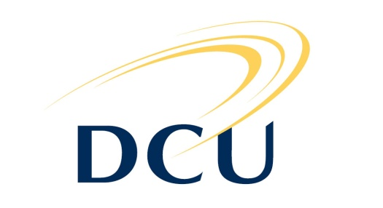 |  | Institute of Ethics  Dublin City University  Ollscoil Chathair Bhaile Átha Cliath  Dublin 9, Ireland  Professor Bert Gordijn  Director

Dublin, 24 July 2014

Dear colleague,

On behalf of the ESPMH Board I would like to invite you to attend the General Assembly of our Society, which will take place during the upcoming conference in Debrecen on Friday, 29 August 2014 (16.30-17.30 hrs). Attached please find the agenda of this meeting as well as the draft report of the last General Assembly in Basel.

The three-year term of office of two Board members will finish by the end of this year (Gerrit Kimsma and Eugenijus Gefenas). This means that these two board positions will be up for election during the General Assembly in Debrecen.

In our email from 17 December 2013 we invited you to nominate candidates for these two positions in the Board of the ESPMH. Subsequent to the invitation to propose candidates, we have not received any nominations. However, both Gerrit Kimsma and Eugenijus Gefenas have indicated to be willing to serve yet another term in their respective positions, Treasurer and Regular Board Member.

Thus, the Board’s election proposal is as follows:

Treasurer: Gerrit Kimsma
Regular Board Member: Eugenijus Gefenas

According to the by-laws concerning the election procedure, a candidate can be elected without ballots if there is only one candidate for a position and the members at the General Assembly unanimously agree.

Bio sketches of the candidates are uploaded on the Society’s homepage at
http://espmh.org/biographical-notes.php .

On behalf of the Board,

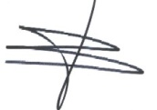

Bert Gordijn, Secretary of ESPMH

