Prof. Bert Gordijn
Secretary of the ESPMH

Institute of Ethics
Henry Grattan Building
Faculty of Humanities and Social Sciences
Dublin City University
Glasnevin, Dublin 9
Ireland

T: + 353 1 700 6140
F: + 353 1 700 6142
E: bert.gordijn@dcu.ie

Letter to the members of the ESPMH

Dublin, 5 August 2012

Dear Colleagues,

On behalf of the ESPMH Board, I would like to invite you to attend the General Assembly of our Society, which will take place in Nazareth on Thursday 23 August 2012 (16.30-17.30 hrs). Enclosed please find the agenda of this meeting as well as the draft report of the 25th General Assembly in Zürich, Switzerland, 19 August 2011.

In our email from 9 December 2011 we invited you to nominate candidates for positions in the Board of the ESPMH. The three-year term of office of two board members will end by the end of this year (Fuat Oduncu, board member and Bert Gordijn, secretary). This means that their positions will be open for election during the General Assembly in Nazareth.

Subsequent to the invitation to propose candidates for these two positions, we have not received any nominations. However, both Fuat Oduncu and Bert Gordijn have indicated that they are willing to serve yet another term. Thus, the Board’s election proposal is as follows:

Board member: Fuat Oduncu
Secretary of the ESPMH: Bert Gordijn

According to the by-laws concerning the election procedure, a candidate can be elected without ballots if there is only one candidate for a position and the General Assembly unanimously agrees. Bio-sketches of the two candidates are enclosed as well.

On behalf of the Board,


Bert Gordijn

Enclosed:

Agenda General Assembly 2012,

Draft report 25th General Assembly Zurich 2011

Bio-sketches candidates

Call for abstracts Basel 2013

EUROPEAN SOCIETY FOR PHILOSOPHY OF MEDICINE AND HEALTH CARE

26th GENERAL ASSEMBLY ESPMH
Nazareth, Israel, 23 August 2011, 16.30-17.30 hrs

Max Stern Yezreel Valley College, (YVC)
Nazareth (Israel)

Agenda

- Draft report of the 25th General Assembly of the ESPMH in Zurich, Switzerland on Friday, 19 August 2011

- Report of the ESPMH Board over 2011
- The secretary: membership; activities
- The treasurer: final account for 2011

- Report of the Financial Review Committee over 2011

- Election of Financial Review Committee for 2012

- Society’s fees

- Preliminary budget 2013

- Election ESPMH Board

- Number of board members with respect to the next election

- Future conferences
- Conference in Basel, Switzerland (August 2013)
- Conference in August 2014
- Further plans

- Journal Medicine, Health Care and Philosophy

- AOB

EUROPEAN SOCIETY FOR PHILOSOPHY OF MEDICINE AND HEALTH CARE
(Draft report)

25th General Assembly ESPMH
Zurich, Switzerland, 19 August 2011, 16.30-17.30 hrs

Attendants (45):
Aiko Sawada (Japan), Ana Borovechi (Croatia), Andrew Edgar (UK), Annette Rid (Switzerland), Anthony Mark Cutter (UK), Antonio Barbosa (), Augusto J. Henriques (Portugal), Bert Gordijn (Ireland), Bjørn Hofmann (Norway), David Badcott (UK), David Hunter (UK), Eleni Kalokairinou (Cyprus), Eugenijus Gefenas (Lithuania), Fabrizio Turoldo (Italy), Francesca Bosisio (Switzerland), Frida Simonstein (Israel), Friedrich Heubel (Germany), Fuat Oduncu (Germany), Gardar Arnason (Finland), Gerrit Kimsma (Netherlands), Jacques Tamin (UK), Jan Payne (Czech Republic), Jeffrey Barker (USA), Jiri Simek (Czech Republic), Joào Calinas-Correia (UK), Kristin Zeiler (Sweden), Kyoichi Ozaki (Japan), Lisa Morberg-Jamterud (Sweden), Luciana Caenazzo (Italy), Margaret Battin (USA), Matti Häyry (Finland), Michael Barilan (Israel), Nathan Emmerich (UK), Niall Scott (UK), Peter Kakuk (Hungary), Petra Gelhaus (Germany), Renzo Pegoraro (Italy), Robert Barnet (USA), Roberto Andorno (Switzerland), Rolf Ahlzen (Sweden), Søren Holm (UK), Stephan Sahm (Germany), Stephen Tyreman (UK), Tuija Takala (Finland), William Stempsey (USA)

- Draft report of the 24th General Assembly of the ESPMH Zagreb, Croatia, Friday, 20 August 2010
The report is approved with one correction: “Zurich (Germany)” on page 1 should be “Zurich (Switzerland)”.

- Report of the ESPMH Board over 2010

- The secretary: membership; activities
During the last year the ESPMH membership has decreased with 214 members from 482 to 268. Most of the time of the secretariat was spent in preparing this year’s conference in Zurich. Several mailings were sent to the members. Moreover, together with Frida Simonstein, first preparations have been made for the 2012 conference in Nazareth (Israel). The Nazareth call for abstracts was launched earlier this year. There have also been talks with Bernice Elger to organise the 2013 conference in Basel (Switzerland); this proposal is on the current agenda. The venue of the ESPMH 2014 conference is still undecided. Thus ESPMH members are invited to submit proposals to host the 2014 conference. A lot of work has been done on the new ESPMH website, which is now up and running. All updated relevant material relating to upcoming annual conferences can be found there. It also has an event list as well as a job list.

- The treasurer: final account for 2010
The treasurer distributes the final account for 2010. After a critical review of the payment of fees by the membership, more than 200 members have been cancelled. 2010 was not a good year, mainly because only a fraction of the members paid their fees (resulting in €5,404.79 – see below). However, €15,741.00 was paid to Springer to cover the expenses for the journal. This situation is unsustainable. Therefore, the ESPMH board has now decided to apply a strict policy with regard to cancelling membership. Members who, after a reminder email, do not pay their membership fee will be cancelled. In addition, they will not receive the journal any more.

Year Account ESPMH 2010
Overview | accounts 2010
INCOME |  |  | EXPENSES
Membership |  |  | Bank costs
Conf acc | 400 |  | Conf acc | 123.03
Postal Giro | 180 |  | Gen acc | 100.62
General acc | 4824.79 |  | Post Giro | 27
 | 5404.79 | 5404.79 |  | 250.62 | 250.62
Conference |  |  | Ogone |  | 476.53
Conf acc | 9978 |  | Cardcie’s |  | 655.53
Post acc | 950 |  | Ch of comm |  | 26.14
General acc | 17760 |  | Board costs |  | 1710
 | 28688 | 28688 | Springer |  | 15741
Interest |  | 525.87 | Zagreb |  | 15137.53
 |  | 34618.66 | Tubingen |  | 1400
 |  |  | Treasury |  | 1500
 |  |  | Secret Dublin |  | 15585.04
 |  |  | Refunds/prize |  | 930
 |  |  | ESPMH site |  | 1503.17
Neg saldo |  | 20297.51
Totals |  | 54916.17 |  |  | 54916.17

- Report of the Financial Review Committee over 2010
David Badcott and Bjørn Hofmann have assessed the account 2010 and state everything is in order. The Financial Account over 2010 is approved by the GA. David Badcott compliments the treasurer over his fine work.

- Election of Financial Review Committee over 2011
Both David Badcott and Bjørn Hofmann would like to continue as members of the Financial Review Committee. David Badcott and Bjørn Hofmann are re-elected as members.

- Society’s fee
The Board proposes that for the time being the fee remains 60 Euros. There is some discussion about the fees. Some members are in favour of a two tier fee structure distinguishing between people from affluent and less affluent countries or between professionals and students. A proposal to this effect is being prepared by Eugenijus Gefenas. It will be discussed in the Board meeting and the General Assembly next year.

- Preliminary budget 2012
Budget 2012
INCOME |  | EXPENSES
Membership fees 250x60 | 15000 | Bank costs | 400
Conference fees 100x350 | 35000 | Card comp | 1000
Interest | 1000 | Ch of comm. | 30
 |  | Printing | 2500
 |  | Secretariat | 8000
 |  | Prices | 1500
 |  | Conference | 20000
 |  | Journal | 7000
 |  | Treasury | 2500
 |  |  | 47930
 |  | Pos saldo | 8070
Totals | 51000 |  | 51000
The budget proposal is approved by the General Assembly.

- Election Members of the ESPMH Board
In an earlier letter to the ESPMH members from 14 December 2010 they were invited to nominate candidates for positions in the Board of the ESPMH. The three-year term of office of two board members will finish by the end of this year (Gerrit Kimsma, Treasurer and Eugenijus Gefenas, regular board member). This means that their positions will be open for election during the General Assembly in Zurich. Subsequent to the invitation to propose candidates for these two positions, the Board has received no response. Luckily, however, both Gerrit Kimsma and Eugenijus Gefenas have indicated that they are willing to serve yet another term. Thus, the Board’s election proposal is as follows:

Treasurer of the ESPMH: Gerrit Kimsma
Regular Board Member: Eugenijus Gefenas

According to the by-laws concerning the election procedure, a candidate can be elected without ballots if there is only one candidate for a position and the General Assembly unanimously agrees. The General Assembly does indeed unanimously agree. Thus both Kimsma and Eugenijus Gefenas have been elected to serve yet another term.

- Number of board members with respect to the next elections
According to the Statutes, the number of positions in the Board has to be settled by the GA. There is no proposal to change the current number of seats. That means that we continue to have 9 board positions. The GA approves that the ESPMH continues to have 9 board members.

- Future conferences
- 2012 ESPMH conference in Nazareth: Frida Simonstein gives a presentation about the upcoming conference in Nazareth.
- 2013 ESPMH conference in Basel: Bernice Elger presents her proposal to host the 2013 conference in Basel. Her proposal is accepted.
- Further plans: A host for the 2014 meeting has still to be found. The secretary invites interesting proposals.
- Journal Medicine, Health Care and Philosophy
“Medicine, Health Care and Philosophy” is doing fine. Not only has the journal been accepted by the ISI, a highly respected abstracting and indexing service of Thompson Reuters. It has also recently received its first impact factor of 0.726 (2010). Both the acceptance by the ISI and the new impact factor have given the journal a boost. As a result the manuscript flow is very good. The secretary thanks all the members of the ESPMH on behalf of the editorial team for their great work as authors and reviewers. The success of the journal is a sign of the viability of the ESPMH. With a view on trying to get more contributions from Eastern and Southern Europe, the current editorial team has been enlarged with two new associate editors: Stefano Simplici from Rome as well as Ana Borovechi from Zagreb.

- A.O.B.
It would be good to have instructions for chairs at the next conference.
BIO SKETCHES

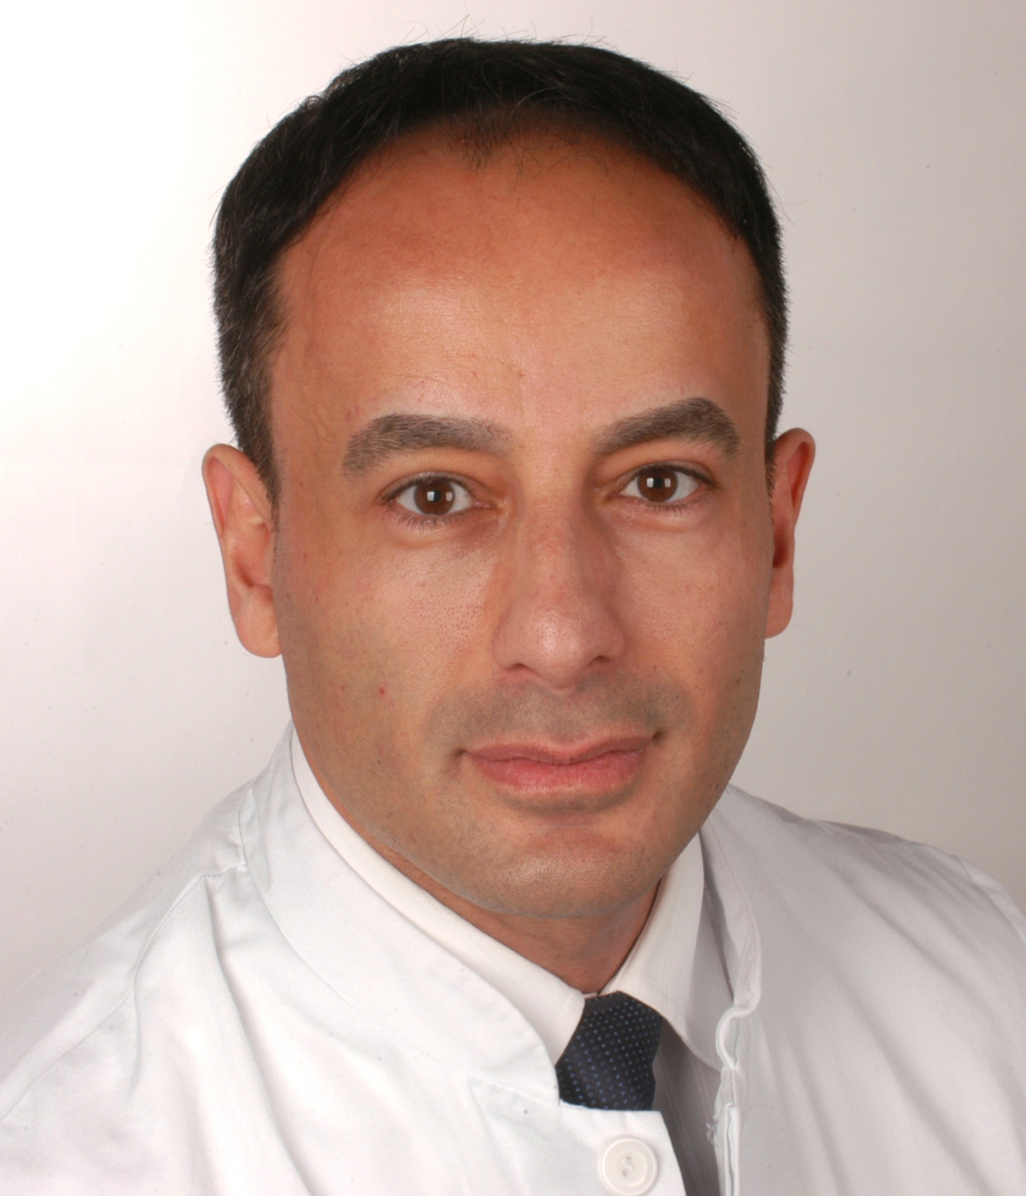

Fuat S. Oduncu
Priv.-Doz. Dr. med. Dr. phil. Fuat S. Oduncu, M. B.A., M.A., European Master in Bioethics, was born in Midyat (Turkey) in 1970. He studied medicine (University of Munich), Philosophy (Jesuite Private University and University of Munich) and Bioethics (European Master in Bioethics at the Universities of Nijmegen, Leuven, Madrid, Padova). In 2005 he passed his Ph.D. in Internal Medicine (Habilitation) at the Faculty of Medicine at the Ludwig-Maximilians-University of Munich. Dr. Oduncu passed several medical qualifications: internal medicine, hematology and oncology, palliative medicine, hemostaseology, and medical quality management. He is the head of the division of hematology and oncology at the University Hospital of Munich. Besides, he teaches medical ethics at the medical faculty of the Technical University of Munich and at the Jesuite Private University. Dr. Oduncu is member of several national and international scientific societies, and member of the Editorial Board of the ESPMH journal Medicine, Health Care and Philosophy. He published more than 200 scientific medical and ethical contributions on hematological malignancies, organ transplantation, brain death, reproductive medicine, embryo research, palliative care, euthanasia, and priority-setting in health care. Dr. Oduncu has been awarded several prizes, among others with the Theodor-Fontane-Preis der Studienstiftung des Deutschen Volkes, Ethik-Preis des Deutschen Allgemeinen Sonntagsblatts, Fellowship for the European Master in Bioethics, Walter-Brendel-Transplantationspreis, Vincenz-Czerny-Preis for Oncology of the German Society for Hematology and Oncology, Fellowship for the M.B.A. Healthcare programme at the Munich Business School and the Boston University School of Management. Most recently he was awarded the prestigious m4-Award for Personalized Medicine by the joint Excellence Cluster of the Bavarian Ministry of Economics and the Federal Ministry of Education and Research.



Bert Gordijn
Bert Gordijn is Professor and Director of the Institute of Ethics at Dublin City University in Ireland. He has studied Philosophy and History in Utrecht, Strasbourg and Freiburg in Breisgau. In 1995 he was awarded a doctorate in Philosophy from the Albert-Ludwigs-Universität Freiburg, followed by a doctorate in Bioethics from the Radboud University Nijmegen in 2003. Bert has been a Visiting Professor at Lancaster University (UK), Georgetown University (USA), the National University of Singapore and the Fondation Brocher (Switzerland). He has served on Advisory Panels and Expert Committees of the European Chemical Industry Council, the European Patent Organisation, the Irish Department of Health as well as UNESCO. Bert is Editor-in-Chief of two book series: "The International Library of Ethics, Law and Technology" and "Advances in Global Bioethics" as well as a peer reviewed journal: "Medicine, Health Care and Philosophy", all published by Springer. He is Secretary of the European Society for Philosophy of Medicine and Healthcare as well as President-Elect of the International Association of Education in Ethics.
27th EUROPEAN CONFERENCE
ON PHILOSOPHY OF MEDICINE AND HEALTH CARE

Innovation in Health Care and the Life Sciences

14 – 17 August 2013
Basel, Switzerland
CALL FOR ABSTRACTS
This conference will be organised by the European Society for Philosophy of Medicine and Healthcare (ESPMH, see http://espmh.org) and the Institute of Biomedical Ethics, University of Basel, Switzerland. The focus of the conference is on Innovation in Health Care and the Life Sciences. There has been an explosion of innovations aimed at enhancing general public health, life expectancy, quality of life, diagnostic and treatment options, as well as the efficiency and cost effectiveness of the health care system. While these innovations potentially have a number of positive benefits, they also raise important philosophical, ethical and social issues. Abstracts addressing these issues in the following categories will be favoured, although work on other topics can also be submitted:

Innovation
- Nature and meaning
- Goals and priorities
- Costs and access
- Technology assessments and ethics
Public health
- Ethical principles guiding innovation in public health
- Public health, innovation and intellectual property rights
- Resources and competing interests
- Priority setting
Biotechnology
- Nanomedicine and Synthetic Biology
- Biosecurity
- Dual-use research of concern
- GM foods
- Reproductive technologies
- Performance enhancement
Information and communication technology
- Storage of biological samples and data
- Telemedicine and ambient assisted living technologies
- Social media and virtual reality
- Lifelogs and lifebraries
Neurotechnology
- Brain computer interfaces, deep-brain stimulation and brain implants
- Neuromodulation, agency and autonomy
- Neuroimaging
- Neuroenhancement

The programme of the conference includes plenary sessions as well as parallel sessions. Anyone wishing to present a paper at the conference should submit an abstract (500 words maximum) before March 1 2013. The Conference Programme Committee will select abstracts for oral presentation. Please send abstracts by e-mail to: Professor Bert Gordijn, Secretary of the ESPMH, Institute of Ethics, Dublin City University, Dublin 9, Ireland (E-mail: bert.gordijn@dcu.ie).

