26th EUROPEAN CONFERENCE
ON PHILOSOPHY OF MEDICINE AND HEALTH CARE

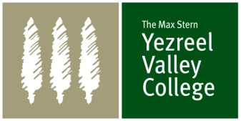
Worst Case Bioethics

21 – 24 August, 2012
Nazareth, Israel

This conference will be organised by the European Society for Philosophy of Medicine and Healthcare (ESPMH) and the Max Stern Yezreel Valley College, Nazareth, Israel. Abstracts addressing the following topics will be favoured, although work on other topics can also be submitted:

Focus

The focus of the conference is on ethical and philosophical issues related to “worst case bioethics”. Abstracts addressing the following topics will be favoured, although work on other topics can also be submitted:

Ethical issues in providing healthcare during war, pandemics and disasters
- Health and human rights
- The mission of WHO in the prevention and control of pandemics
- Ethical dilemmas in triage
- The role of physicians in war

Risk assessment in public health
- Responsibilities of risk assessment agencies
- Ethics and the pharmaceutical industry
- Risk assessment for exposure to chemicals and nanomaterials
- The precautionary principle

Dealing with fatal conditions
- Truth-telling and cancer patients
- Palliative care and pain relief
- Strengths and shortcomings of advance directives
- Decisions about life sustainment treatments

Bioethics and international justice
- Setting priorities at an international scale
- Addressing the 10/90 gap
- Prevention of trafficking of human organs
- Benefit sharing in human research.

Bioethics and intergenerational justice
- The debate on liberal eugenics
- Is there a duty to preserve the human species?
- Problems associated with reproductive technologies
- Human cloning and germ-line interventions
- Synthetic biology

Important Dates

1 March 2012: Deadline for submission of abstracts
1st half of March 2012: Selection of abstracts
2nd half of March 2012: Draft programme
1 April 2012: First deadline for registration and payment

Language

The language during the conference will be English.

Organisation

The registration process, call for abstracts, development of the programme, publication of programme announcements and mailings to participants is taken care of by the ESPMH Secretariat in Dublin, Ireland.

ESPMH Secretary:

Prof. Bert Gordijn
Secretary of the ESPMH (www.espmh.org)
Institute of Ethics, Dublin City University
Henry Grattan Building
Glasnevin,
Dublin 9, Ireland
T: + 353 1 700 6140
E: bert.gordijn@dcu.ie

Local Conference Coordinator:

Max Stern Yezreel Valley College,
Nazareth, Israel

Contact person:

Dr. Frida Simonstein
Dept. of Health Systems Management
Yezreel Valley College
19300 Emek Yesreel, Israel
T: + 972-4-6270 868
F: + 972-4-6270 946
E: fridas@yvc.ac.il

The Max Stern Yezreel Valley College

The Max Stern Yezreel Valley College is the leading institution of higher education in the Galilee, with over 5000 students.

The College is located in the beautiful Yezreel Valley in the north of Israel, in the outskirts of the historical city of Nazareth which has a mixed population of Christian and Muslims Arabs, and Jews. Faculty members devote constant effort to the education and training of the college's diverse student population, believing that Israel's future as a pluralistic democracy depends on the spread of knowledge and modern skills in peripheral regions of the country.

The College integrates research and hands - on professional experience through community work and involvement with various community organizations. This experience provides students with real – life demonstration of theoretical concepts in a professional environment, thus establishing an even stronger bond between our students and the social and economic reality of Israel's northern communities.

The Department of Health Services Management

The department was established close to a decade ago to respond to needs that concern present day Israeli society for education and training of professionals in the health field, both in health care and in management. Up to the current academic year, over 1000 students have graduated from the department, most of them nurses and health professionals, and about 130 from management fields. Graduates remain in close contact with the department.

The department is geared to two main target populations: students in the health professions – certified nurses, physiotherapists, paramedics and the like; and students working in various administrative and managerial roles within the health system, or those who plan a career in the system. Currently some 300 students are enrolled in the department.

The Department of Nursing

The Nursing Department at YVC trains highly qualified, culturally sensitive and socially responsible nurses, who rapidly integrate in Northern Israel's healthcare system. The academically demanding study program involves work in the Grinspoon Simulation Laboratory, and clinical practice in the second, third and fourth years of study.
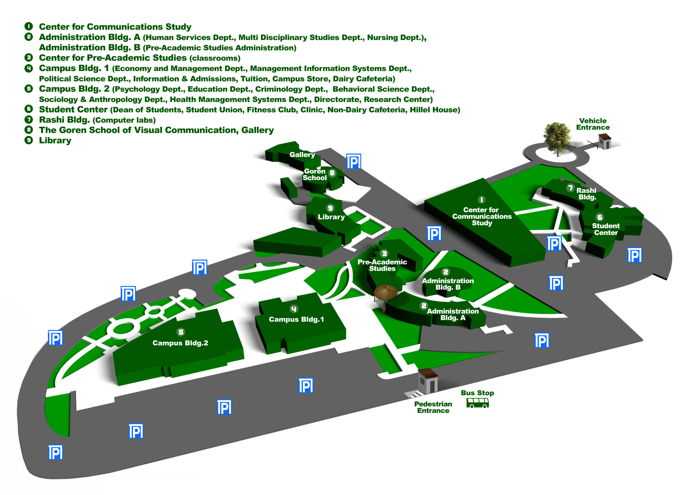
The Max Stern Yezreel Valley College map

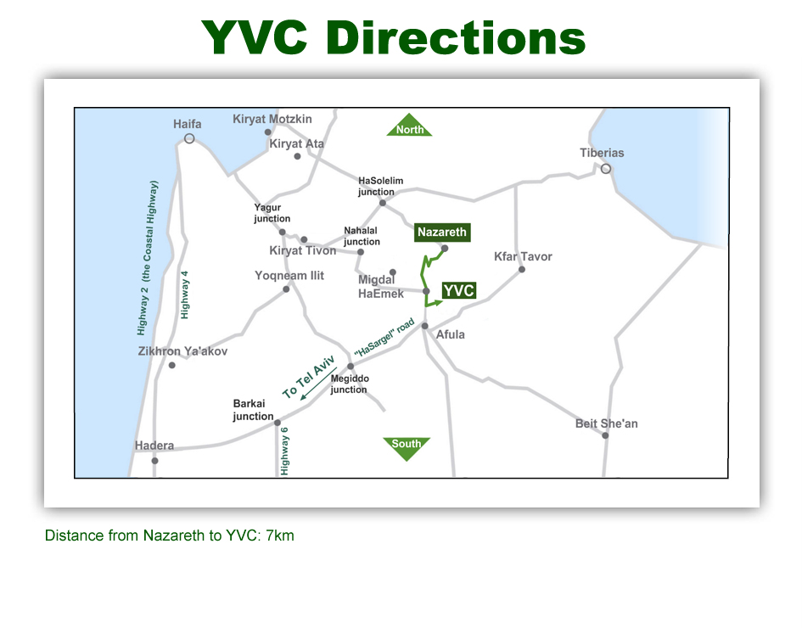

Registration

A registration form can be downloaded from the ESPMH website (www.espmh.org) which should be returned no later than 01 April 2012, including the registration fee. The latter should be transferred to the ESPMH Treasurer (details provided on the registration form). The registration fee includes: welcome reception (Tuesday), two lunches, refreshments during breaks, conference dinner (Thursday) and an abstract booklet. The registration fee for accompanying persons includes the welcome reception (Tuesday) and the conference dinner (Thursday).

Registration Fee

NB: The registration fee for participants who are not a member of ESPMH is higher than for ESPMH members.

Participants:

Paid before 1 April 2012:

ESPMH member: € 350
Non member: € 400

Paid after 1 April 2012:

ESPMH member: € 410
Non member: € 460

Accompanying person:

Paid before 1 April 2012: € 100
Paid after 1 April 2012: € 120

Getting to Nazareth

By air:
Ben Gurion international airport:
Around 50 international airlines fly to Ben Gurion airport from around the world.

By car:
Nazareth is in the northern part of Israel, in the Lower Galilee – a ride of about one and a half hours from Tel Aviv and one hour from Haifa.

Public transport:
From the airport to Jerusalem: take bus line 947 (7:00-21:00, every 20 minutes, 20 NIS).
To Tel-Aviv and the rest of the country: take the direct Tel-Aviv train (3:53-23:23, every half an hour during day, every hour during night, 12 NIS).
From Tel-Aviv to Nazareth: continue by train or bus. Nazareth is 102 km from Tel Aviv and 131 from Jerusalem. Take a bus number 823 or 826 from Tel Aviv New Central Bus Station directly to Nazareth (does not operate on Sabbath or Jewish holidays). The journey takes about 2 hours, or about an hour from Haifa (bus 331 from station Merkaz Hashmona - operates daily including the Sabbath and holidays).
From Jerusalem, there are two direct buses per day - excluding Sabbath and Jewish holidays (bus number 955) or take a bus to Afula and switch to a bus to Nazareth.

By Taxi (for 7 persons): 30 Euro per person

For travel in Nazareth you might want to contact Mrs Sarah Elrom (see her contact details below)

A visit to Nazareth is a unique experience. Having biblical roots Nazareth attracts Christian, Muslim and Jewish tourists. It offers hotels of various levels, from luxurious to budget. Apart from many religious and biblical spots Nazareth is famous for its oriental market and its excellent Middle Eastern food. City tours, tours to the Sea of Galilee and other historical spots in the north of Israel and other locations in Israel can be arranged upon request.

Currency

The unit of currency in Israel is the Israeli Shekel ILS (1 ILS ≈ 0.20 Euro). Foreign currency can easily be exchanged at the airport or at exchange bureaus. All major credit cards are accepted, mainly VISA, and MASTER CARD. Credit cards are accepted in most hotels and shops (but not in the public transport system, were you will need cash).

Visa
Please contact your local consulate for details.

Social Programme

The following social activities will be offered (draft):

- Welcome reception on Tuesday (21 August)

- Wednesday, 22 August, Elective guided tour with a bus from YVC to Tiberias and to some of the holy places, and then to a Galilee Shehezada night – on top of Mount Arbel in a shepered’s tent overlooking the sea of Galilee, magnificent Galilee dinner party – wine & dine- and a belly dancer that will make you all join in. Price: 60 Euro ($ 84) pp. including: bus, tour guide, welcome buffet, dinner including free beer and wine, a belly dancer and a surprise.
  - Minimum for the event, registration of 90 people.

If you would like to join this tour and dine in Tiberias on August 22, please use the link
Form Accommodation – Social Event on the home page and send the completed form
per email or fax to:

Ofakim Travel and Congresses - Mrs. Sarah Elrom
(fax: +972-37610799; e-mail: sarah@ofakim.co.il; tel: +972-3-7610803)

- Conference dinner on Thursday (23 August) – Guided tour with a bus from YVC to Nazareth. Will take us for a tour at the church of the Annunciation and other interesting locations at the city. We will have Gala Dinner, Israeli/oriental style at St. Gabriel Hotel in Nazareth, a former monastery with a panoramic view overlooking the city. The event is outside at the colourful garden. Including: Bus, tour guide, dinner.

- Elective excursions and tours for participants and accompanying persons.

A ‘Must’ during a visit in Israel: Jerusalem and the Dead Sea

To get information and help about tours in Israel:

Mrs. Sarah Elrom
OfakimTravel & Congresses Ltd, Tel-Aviv
Tel: +972+3+7610803
E-mail: sarah@ofakim.co.il

Accommodation

Accommodation in Nazareth is the responsibility of conference participants themselves.
The Max Stern Yezreel Valley College has reserved a contingency of rooms in three locations:

- Nof-Tavor Hotel. (3* hotel) Walking distance from YVC
(see http://www.nof-tavor.com)

- Rimonim Hotel, Nazereth. (4* hotel) Located in center of Nazereth
(see http://www.inisrael.com/rimonimhotels/?cat=5)

- Golden Crown Hotel (5* hotel) Overlooking the magnificent view of the Jezreel Valeey. Great restaurants, nice Lobby, swimming pool, spa, gym
(see http://english.goldencrown.co.il/(

There will be shuttle transport in the morning to YVC and in the evening back to Nazereth.

If you would like to join this tour and dine in Tiberias on August 22, please use the link
Form Accommodation – Social Event on the home page and send the completed form
per email or fax to:

Ofakim Travel and Congresses - Mrs. Sarah Elrom
(fax: +972-37610799; e-mail: sarah@ofakim.co.il; tel: +972-3-7610803)

Directions from Hotel Rimonim Nazareth to the Max Stern Yezreel Valley College

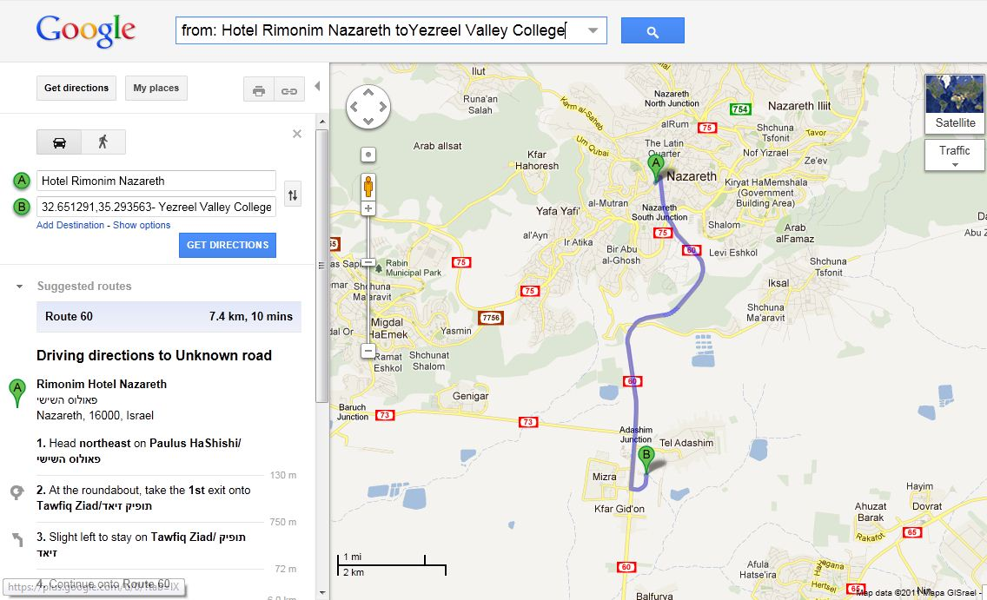

Abstract Book

The abstract booklet will be handed out in YVC at registration. Full manuscripts can be submitted for publication in the ESPMH journal Medicine, Health Care and Philosophy. A European Journal. Participants are invited to read the instructions for authors on the website of the Journal (http://www.springer.com/medicine/journal/11019) and to submit an appropriately prepared article online for review.

About Israel

You can find information on http://www.goisrael.com/tourism_eng

About Nazareth

A visit to Nazareth is a unique experience. Having biblical roots Nazareth attracts Christian, Muslim and Jewish tourists. It offers hotels of various levels, from luxurious to budget. Apart from many religious and biblical spots Nazareth is famous for its oriental market and its excellent Middle Eastern food. Nazareth lies at the southern end of the Galilee Mountains. The heart of Nazareth is the Old City with an inner core of historical and religious buildings together with its outer markets, and surrounded by mansions and houses which compete for space on the slopes of the ridge. Today Nazareth is a bustling city of 80,000 inhabitants, making it the largest Arab city in Israel. It is also at the economic and cultural center for a larger Arab population, at least twice that size, living in several towns adjacent to the city. Most of the local population depends on tourism, service industries, marketing and crafts.

Christian visitors will want to see all the historic sites in the city and to soak up the atmosphere of the place that shaped Jesus' character. They will want to walk through the quaint lanes, visit the markets, meet local residents, and see Nazareth Village, a re-creation of Nazareth and its culture as Jesus would have known it.

We have arranged two hotels for the meeting (see above) but Nazareth offers a wide range of accommodation. There are hotels ranging from three to five stars, two monasteries high on the ridge above the city that have been converted into guest houses, and hostels in the Old Market that offer budget accommodation in spectacular surroundings.

City tours, tours to the Sea of Galilee and other historical spots in the north of Israel and other locations in Israel can be arranged upon request. Please contact

Mrs. Sarah Elrom
OfakimTravel & Congresses Ltd, Tel-Aviv
Tel: +972+3+7610803
E-mail: sarah@ofakim.co.il

